**TCP/IP Two Doors Access Controller Guide**

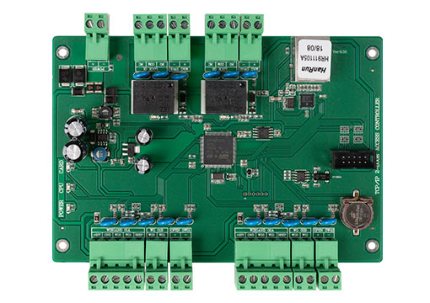

SXK-5924T two doors access control board adopts super network processor combined with mass storage to realize real networked data exchange, data high-speed calculation and super user data management.

It work with large storage capacity, communication management (five computers can manage simultaneously), support regional interlock, regional himself back, fire linkage, the second generation card card number, dynamic qr code algorithm, reached out to new features such as cloud platform. Adopt 100MTCP/IP communication mode, truly realize networked data management, can manage a door, and support 42,000 user data, 200,000 event record storage, provide a group of 7A lock relay output.

* **Farameters:**

Working Voltage: DC9V-14V

Working Current: < 350mA

Temperature and Humidity: -40℃-75℃ (10-90%RH non-frost)

Door Control: 2

Readers: 4

Exit Switch: 2

Door Sensor Interface: 2

Relay: 2

Alarm Extesion: 4 enter and 4 exit (fire alarm, bandit alarm, burglar alarm, Gas alarm)

Reading Protocol: Wiegand 26 \ Wiegand 34 \ Wiegand 66

Register cards: 42,000 (Can be extended)

Record Capacity: 200,000 (Can be extended)

Communication Type: TCP/IP（10/100M）

Communication Distance: TCP/IP (100m)

Wiegand: 100m (Suggest 80m)

Size: 157*130*20mm

**System Functions:**

SXK-5900 series support (standard functions) : Offline operation, read the card to open the door, the password to open the door, time control password valid, read card + password to open the door, the time control card + password valid, manually enter the card number, password to open the door, the first card to open the door, always open card to open the door, open the remote, remote, time to open the door, time normally open, real-time monitoring, abnormal monitoring, electronic maps, duress alarm, fire linkage, police bandit alarm, intrusion alarm, alarm, report the loss of card, card reader to the blacklist illegally card read alarm, open tip/overtime alarm, anti-submarine defense followed, bulk upload, a small amount of upload, two-door interlock, many interlock, multiple cards to open the door, keyboard operation, emergency shutdown, access control attendance, 64 Group opening hours, holidays, etc.

SXK-5900 series support (professional functions) : record card back, repair, prevent detection lock, card read calibration, all card to open the door, open card + all automatic registration, the main board buzzer switch, clock repair itself, the internal and external certification. Open the door, 3 + 1 to open the door, door number query, report to the police telephone calls after the notification, the device has been running days, remote hardware upgrade, etc.

SXK-5900 series support (new function) : in addition to the above functions, we also add technology that is not available or rare for other similar products in the market, such as: Card reader circuit anomaly detection and prompt, temperature detection system environment, and the input power supply temperature on-line monitoring, trial periods, entrance guard patrolling, validity card expired early hint, intelligent clock error corrections, every day out of the door switch controlled by time period, the remote reading card photo, anti-theft alarm host function and interval, door magnetic card reader to the alarm time management, communication encryption data, card number, capacity expands itself, more efficient machine concurrent communication management (maximum 5 computers at the same time control), regional interlock, regional himself back, fire linkage, the second generation card card number, dynamic, take the initiative to contact cloud platform, Wiegand QR code algorithm, Wiegand keyboard issues cards.

SXK-5900 series support (site access control function) : it supports the management of pedestrian turnstile, can realize two-ways control, provides LED screen information output, LCD TV screen information output, supports site information display, can support card reading, fingerprint, face (a set of software unified management), and supports multi-platforms data upload.

The above models can choose FCARD3500 software or the updated version of the one card pass management system software, the software system supports ACCESS and SQL database, support local connection communication, but also remote Internet communication.

**Wiring Diagram:**

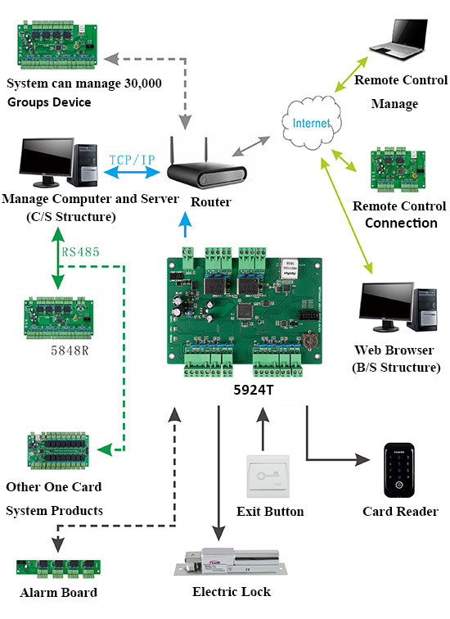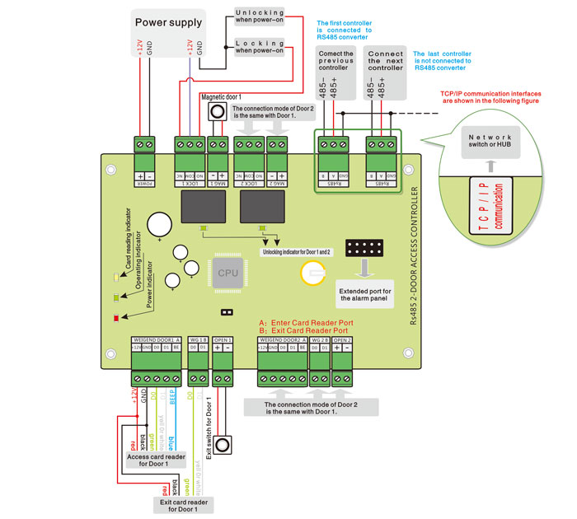

**Wiring requirements：**

1. AC220V ac power cord: it is recommended to use 3* 1.0mm square (or above) wire to prevent power leakage and grounding of the power cord.

2. Electric locking wire: 2* 1.0mm square (or above) wire must be used, and the maximum length of the line shall not exceed 50m.

3. TCP/IP communication line: standard network line shall be adopted, and the maximum line length shall not exceed 100 meters.

4. Card reader wire: it is recommended to use 8*0.5 square mm (or above) wire, the longest line line shall not exceed 80 meters.

5. Door sensor or door switch wire: it is recommended to use 2*0.5 square mm (or above) wire, and the wire length shall not exceed 100 meters.