**SFP(BIDI) Optical Transceiver**

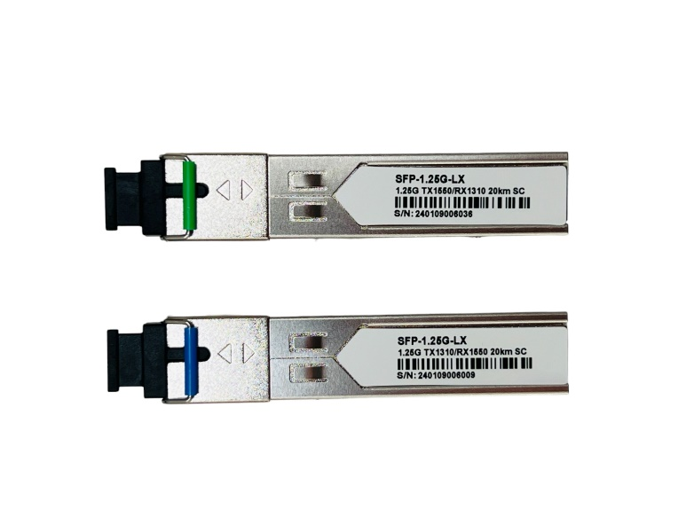

The SFP optical module is a hot-plug, small form-factor module, only thumb-sized, supporting SONET, Gigabit Ethernet, Fiber Channel, and other communication standards.

**STANDARDS COMPLIANCE**



**SPECIFICATION**

|  |  |
| --- | --- |
| Specification | Details |
| Package Model | SFP (BIDI) |
| Operating Temperature | 0-75℃ |
| Wavelength | TX1310nm/Rx1550nm |
| Tx1550nm/Rx1310nm |
| Transmission Distance | 20KM |
| Transmission Rate | 1.25G |
| Transport Interface | LC SX |

**ELECTRICAL CHARACTERISTICS**

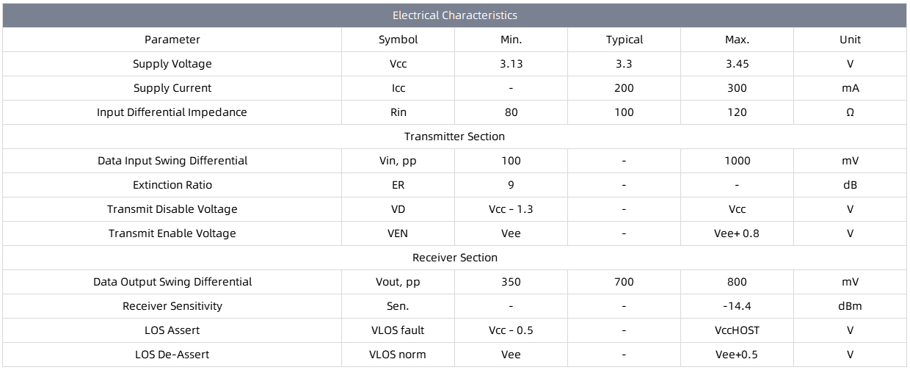

**COMPATIBLE BRANDS**

