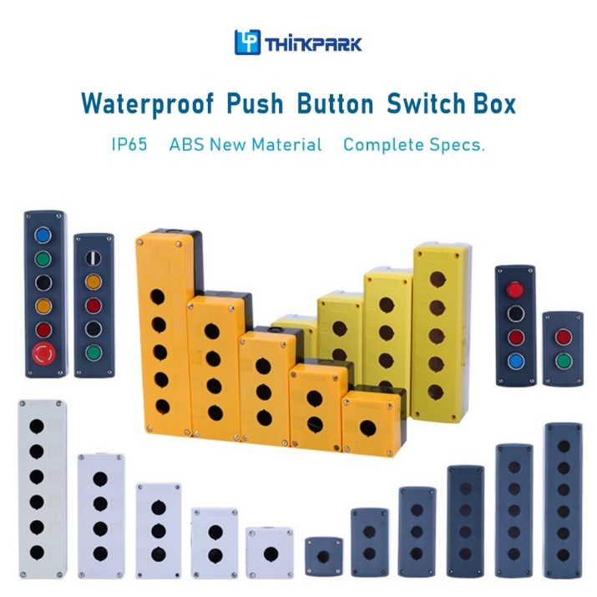Specification

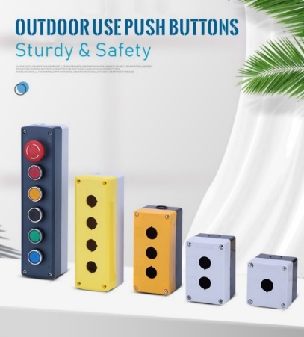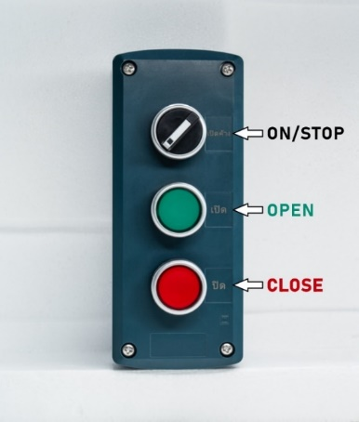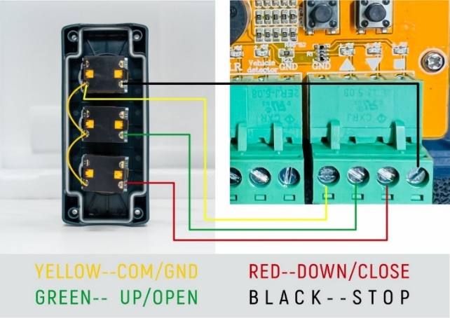

|  |  |
| --- | --- |
| Item | Spec. |
| Material | ABS |
| Product name | Manual Push Button Switch Box |
| IP Grade | IP65 |
| Contact | NO, NC, COM |
| Holes | 1-6 |
| Operation type | push button box |
| Life cycle | 5 million  mechanical life, 500,000 electrical life |
| Contact material | copper based silver point |