Monitor Touch Screen 17 inch Kiosk

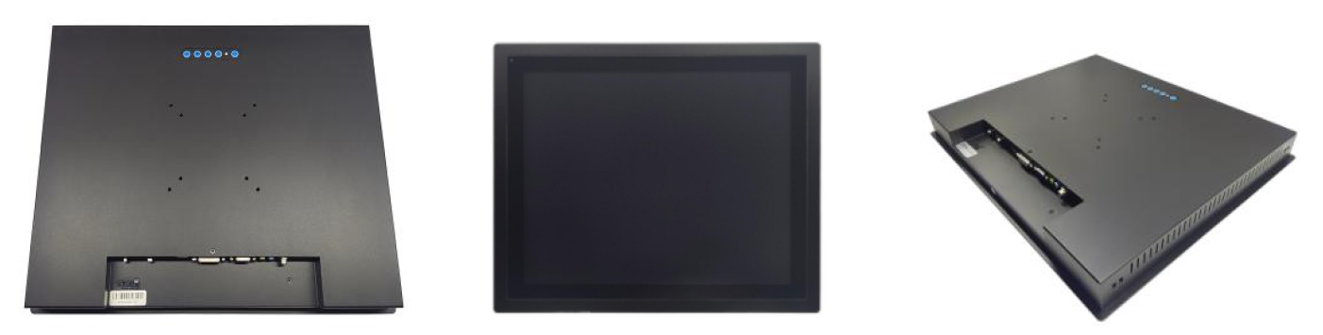

Features:
- Front 3mm bezel aluminum alloy brushed metal craft, seamless design, front IP65 waterproof and dustproof.
- Industrial LCD panel, wide viewing angle, high nits, true color.
- Adopt multi-points PCAP touch panel, high sensitive and fast-response. Covered with 2mm tempered glass for vandalproof.
- 1000 nits, sunlight readable
- Anti glare. Optical Bonding
- High performance mainboard, 7x24 continuous operation.
- Wide temperature range: operating: -20 to 70C, storage: -30 to 85*C.
- Support wall mounting, embedded mounting, desk stand mounting etc.
