**Loop Detector PD-182**

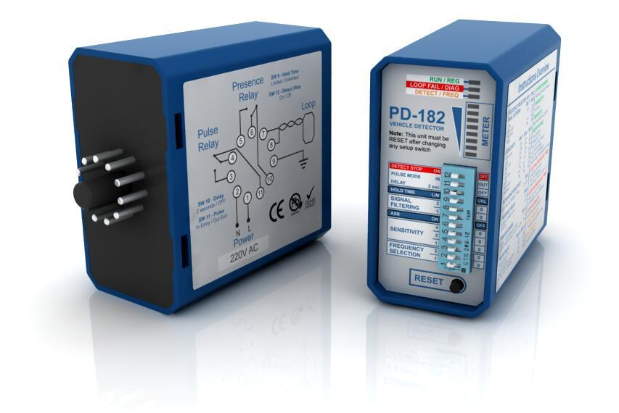

**Product Description**

Loop detector, also called vehicle loop detector, inductive loop detector, loop sensor, loop controller, traffice light detector it used to traffice light , automatic gate, wing gate, parking barrier gate, road bollard and related vehicle access control system.

PD-182 Single Channel Vehicle Loop Detector allows for detection of metalic objects entering into the field formed around the detection loop. We have designed PD-182 with the following objectives in mind:

1. Fully compatible with most popular 11 pin loop detector of market.

2. Diagnostic capabilities using LED, without external accessories.

3. Frequency display using LED to show real frequency working between 50Khz to 200Khz

4. Level Meter using LED to show in real time any detection from loop field.

5. More options like four frequency, eight sensitivity level, four signal filtering.

6. Loop isolation protection for lightning and transient damage.

7. Selectable permanent presence (to eliminate premature barrier / gate closure )

8. High quality components from Germany and Japan for high stability of detection

9. DETECT STOP function allows detection only when a vehicle has come to a complete stop on the loop.

**Technical Date**

Operating voltage: 220v, 110vAC 24v,12vDC

Power Consumption: ≥5VA

Output relays: 240V/5A AC

Frequency range: 20 kHz to 170 kHz

Reaction time: 10ms

Signal holding time: Unlimited / limited when loop is permanently covered 10 minutes

Sensitivity: adjustable in 8 increments

Wiring: 50μH and 300μH. Ideal is 150μH

Loop connection wiring: Maximum length 200 meters,twisted at least 20 times per meter

Autocorrecting time: 1to 2seconds

Operating temperature: -40°C to +82°C

Storage temperature: -40°C to +85°C

Dimensions (include pedestal ): 78x42x108 mm (L x W x H)

Net Weight (include pedestal): 275g