**LPR100 HD all-in-one exit/entrance LPR Camera (license plate recognition)**

As the latest plate recognizing camera launched by Thinkpark, LPR100T HD all-in-one exit/entrance LPR has made a big leap than previous generations in electrical protection, adaptability to complicated lighting conditions, overall plate recognition rates and plate recognition algorithms. Widely applied at the exits/entrances of parking lots, 4S stores, highways as well as checking stations, the product is first choice for plate recognition system integration.

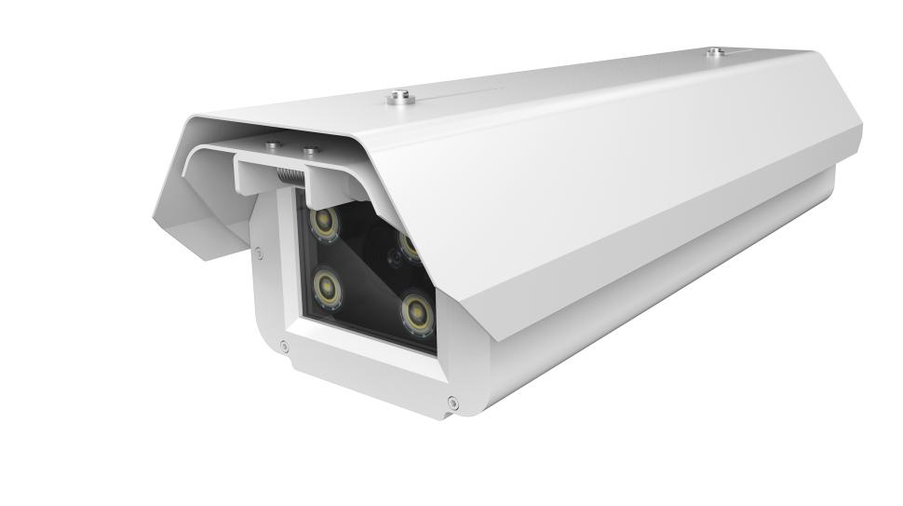

Product features

I. High-precision vehicle detection algorithm

* The mature video vehicle detection technology can identify vehicles running at 0~40km per hour without stopping them for card swiping or embedding ground loops.
* support virtual loop-based unlicensed vehicle detection

II. Making better use of data value

III. Adaptive to complicated environments

* The 70-degree wide angle plate recognition can work under a variety of special circumstances: wide roads, short depth, vehicles from multiple directions, etc.
* Support ultra-wide dynamic image optimization and dynamic adjustment of plate image parameters, and adapt to complicated lighting scenarios: front/back lighting, inconsistent front/back plates, rain/snow

IV. Support diversified businesses

* Support built-in black/white lists
* Free SDK; support multiple linking solutions such as the dynamic link library (DLL) and com components; support a variety of development languages like C, C++, C#, VB, Delphi, Java, etc.

|  |  |
| --- | --- |
| Indexes | |
| Name | Parking Entrance ALPR Camera |
| Model No. | LPR100 |
| Cpu | Hisilicon, specialized license plate recognition chip |
| Sensor | 1/3" CMOS Image Sensor |
| Minimum illumination | 0.01Lux |
| Lens | 6mm fixed focus lens |
| Built-in light | 4 high-power LED white lights |
| Performance Indexes | |
| Plate recognition accuracy | ≥97% |
| Plate types | Overseas licence plate |
| Triggering mode | Video trigger, coil trigger |
| Image output | 1080P(1920x1080)，960P(1280x960)，720P(1280x720)，D1(704x576)，CIF(352x288) |
| Picture output | 2 mega-pixel JPEG |
| Video compression format | H.264 High Profile , Main Profile, Baseline , MJPEG |
| Interface parameters | |
| Network interface | 10/100，RJ45 |
| IO | 2 input & 2 output 3.5mm connecting terminals |
| Serial interface | 2 x RS485 |
| Audio interface | 1 input & 1 output |
| SD card | Support SD2.0 standard Micro SD(TF) card with a maximum capacity of 32G |
| Power supply | AC220V |
| Power consumption | ≤7.5W |
| Working temperature | -25℃~+70℃ |
| Protection grade | IP65 |
| Size（mm） | 452(L)*148(W)*120(H) |
| Weight | 2.7kg  **Dimensional drawing (mm)** |

**Parameters**