**Housing For IP LPR Camera**

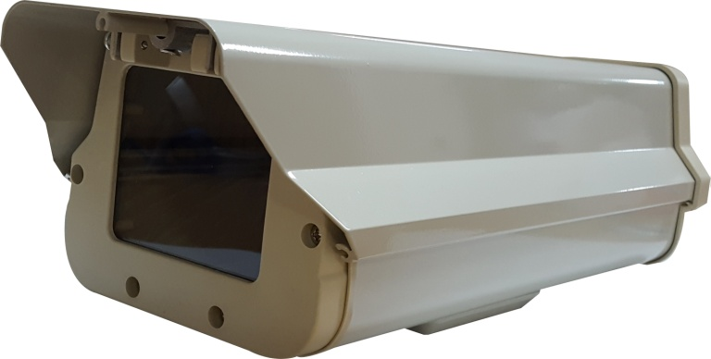

Model HZ30B

Product Features Infrared light board can be installed

Protection Level IP65

Material Main: aluminum alloy; Window: glass (optional); Lock:304 stainless steel

Surface Treatment Spray paint

Color Off-white

Installation Method Bottom installation

Glass Lens Hole Size φ30mm (optional)

Dimension ( external ) 370*120*105mm

Dimension ( internal ) 300*106*85mm

Working Temperature ˗35°C~65°C

Power Consumption heater: 25w; fan: 4w (optional)

Automatic Temperature Control Range Heater on: about 8°C±5°C, fan opertation for constant temperature, off 20°C±5°C; Fan on: about 37°C±5°C, for heat dissipation, off 20°C±5°C