**Product Datasheet**

**10-port Full Gigabit PoE Switch**

**(H3108PS)**

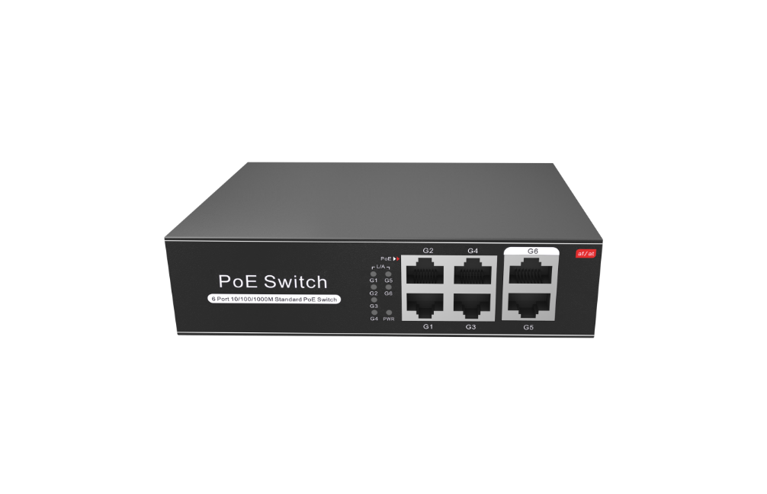

**OVERVIEW**

The H3108PS is a full gigabit unmanaged PoE switch. It has 10*10/100/1000Base-T RJ45 ports. Port 1-8 can support PoE+ power supply, and single-port PoE power up to 30W. As a PoE power supply device, it can automatically detect and recognize the power-receiving equipment that meets the standard and supply power through the network cable. It can supply power to POE terminal equipment such as wireless AP, IP camera, VoIP phone, video access control intercom, etc. through a network cable to meet the network environment that needs a high-density PoE power supply. It is suitable for hotels, campuses, factory quarters, and small and medium-sized enterprises to form an economy-efficient network. Unmanaged model, plug and play, no configuration, easy to use.

**FEATURE**

* **Full gigabit rate, dual RJ45 ports uplink**
* Support IEEE 802.3x full-duplex flow control and Backpressure.
* Support non-blocking wire-speed forwarding for smoother transmission.
* Provides Gigabit Ethernet ports and dual RJ45 ports uplink for flexible networking and meets the networking requirements of various scenarios.
* **Smart PoE power supply**
* 8*10/100/1000Base-T PoE ports can support PoE power to meet the needs of security monitoring, teleconferencing system, wireless coverage, and other scenarios.
* The PoE port supports the priority mechanism. When the remaining power is insufficient, the power of the high-priority port is given priority to avoid overloading of the device.
* Comply with PoE+ power supply standard, automatically identify PoE devices for power supply without damaging non-PoE devices, and the single port max PoE output power is 30W.
* **Stable and reliable, easy to use**
* CCC, CE, FCC, RoHS.
* Plug and play, no configuration, simple and convenient.
* The user-friendly panel can show the device status through the LED indicator of PWR, Link, and PoE.
* Self-developed power supply, high redundancy design, providing a long term and stable PoE power output.
* Low power consumption, no fan, galvanized steel casing, excellent heat dissipation to ensure the stable operation of the switch.

**TECHNICAL SPECIFICATION**

|  |  |  |
| --- | --- | --- |
| **Model** | **H3064PS** | **H3108PS** |
| **Interface Characteristics** | | |
| Fixed Port | 4*10/100/1000Base-T PoE ports (Data/Power)  2*10/100/1000Base-T uplink RJ45 ports (Data) | 8*10/100/1000Base-T PoE ports (Data/Power)  2*10/100/1000Base-T uplink RJ45 ports (Data) |
| Ethernet Port | Port 1-6/ 1-10 support 10/100/1000Base-T auto-sensing, full/ half duplex MDI/ MDI-X self-adaption | |
| Twisted Pair Transmission | 10BASE-T: Cat3, 4, 5 UTP (≤100 meters)  100BASE-TX: Cat5 or later UTP (≤100 meters)  1000BASE-T: Cat5e or later UTP (≤100 meters) | |
| **Chip Parameter** | | |
| Network Protocol | IEEE802.3 10BASE-T, IEEE802.3i 10Base-T  IEEE802.3u 100Base-TX, IEEE802.3ab 1000Base-T, IEEE802.3x | |
| Forwarding Mode | Store and Forward(Full Wire Speed) | |
| Switching Capacity | 16Gbps (Non-blocking) | 20Gbps (Non-blocking) |
| Forwarding  Rate@64byte | 8.93Mpps | 14.88Mpps |
| MAC | 8K | 2K |
| Buffer Memory | 2M | |
| Jumbo Frame | 9.2k | |
| LED Indicator | Power: PWR (Green), Network: Link (Green), PoE: PoE (Green) | |
| **PoE & Power Supply** | | |
| PoE Port | Port 1 to 4 | Port 1 to 8 |
| Power Supply Pin | 1/2(+) 3/6(-) | |
| Max Power Per Port | 30W, PoE+ | |
| Total PWR / Input Voltage | 65W/ (AC100-240V) | 100W/ (AC100-240V) |
| Power Consumption | Standby <5W, Full load <65W | Standby <6W, Full load <100W |
| Power Supply | Built-in power supply, AC100~240V 50-60Hz, 1.1A | Built-in power supply, AC100~240V 50-60Hz, 2.2A |
| **Physical Parameter** | | |
| Operation TEMP / Humidity | -20°C~+55°C, 5%~90% RH Non condensing | |
| Storage TEMP / Humidity | -40°C~+75°C, 5%~95% RH Non condensing | |
| Dimension (L*W*H) | 142*115*40mm | 195*130*40mm |
| Net /Gross Weight | 0.55kg / 0.8kg | 0.75kg /1.0kg |
| Installation | Desktop, Wall mounted | |
| **Certification & Warranty** | | |
| Lightning Protection | Lightning protection: 4KV 8/20us, Protection level: IP30 | |
| Certification | CCC, CE mark, commercial, CE/LVD EN62368-1, FCC Part 15 Class B, RoHS | |
| Warranty | 1 year, lifelong maintenance. | |

**DIMENSION**

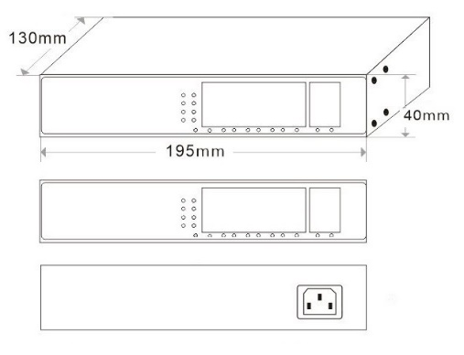

**APPLICATION**

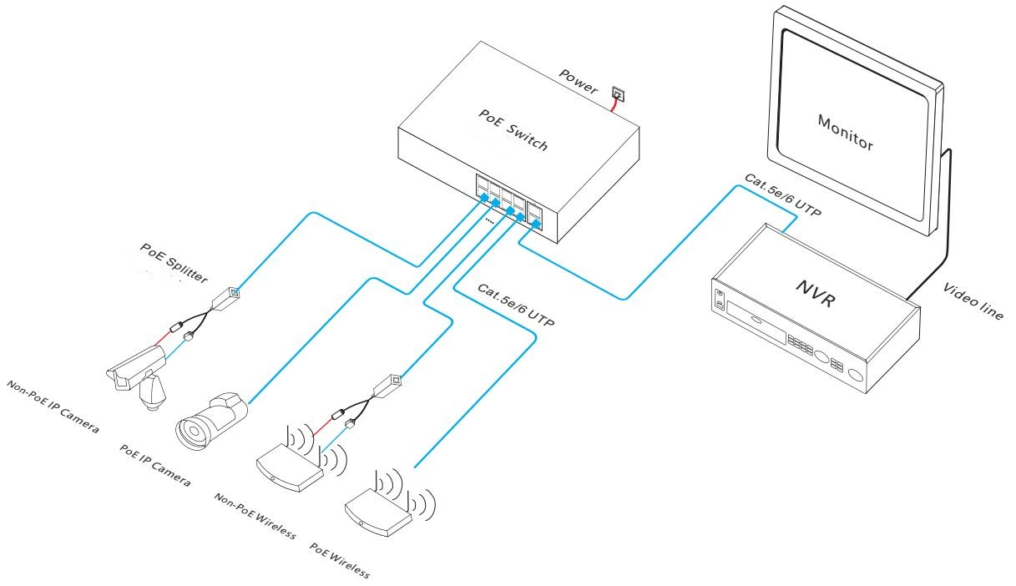

**ORDERING INFORMATION**

|  |  |
| --- | --- |
| **Model** | **Description** |
| H3064PS | Unmanaged PoE switch with 6*10/100/1000M RJ45 ports. Port 1-4 can support PoE+ power supply. Built-in 65W power supply. |
| H3108PS | Unmanaged PoE switch with 10*10/100/1000M RJ45 ports. Port 1-8 can support PoE+ power supply. Built-in 100W power supply. |

**PACKING LIST**

|  |  |  |  |
| --- | --- | --- | --- |
| **Packing List** | **Content** | **Qty** | **Unit** |
| 10-port full gigabit PoE switch | 1 | SET |
| AC Power Line | 1 | PC |
| User Guide | 1 | PC |
| Warranty Card | 1 | PC |