**Infrared Sensor Exit Button**

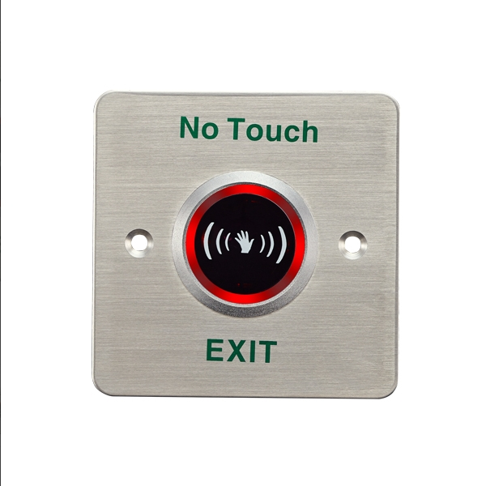

Model:TP-841C(LED)

TP-841C is an Infrared Sensor Exit Button with stainless steel in size of 86Lx86Wx25.7H(mm) suitable for all kinds of locks.4-12cm induction distance is adjustable,1~25S Time delay is adjustable.Red LED indicator:Power ON(standby); Green LED indicator: Power ON(sensation).

**Technical Parameter**

|  |  |  |
| --- | --- | --- |
| Product Parameter | | Parameter Description |
| Dimensions | 86Lx86Wx25.7H(mm) | |
| Input | DC12V | |
| Contact Rating | 1A@30VDC | |
| Output Contact | NO/NC/COM | |
| Mechanical Life | 100,000 tested | |
| Material | Stainless | |
| Suitable for Door | Hollow Door | |
| Operating temp | -20℃~+50℃(14-131F) | |
| Suitable Humidity | 0-95%(relative humidity) | |
| Detection range | 4-12cm(Adjustable) | |
| Time delay | 1~25s(Adjustable) | |
| LED Indicator | Red LED indicator: Power ON(standby) Green LED indicator:Power ON(sensation) | |
| Weight | 0.2kg | |

**Advantages**

Design without Mechanical Bolt

Stainless steel Panel with Elegant Style

Tested to 100,000 Cycles

Three Contact Output,Suitable for all kinds of locks

The Best Choice of Access Control