Electric Bike Charging Pile

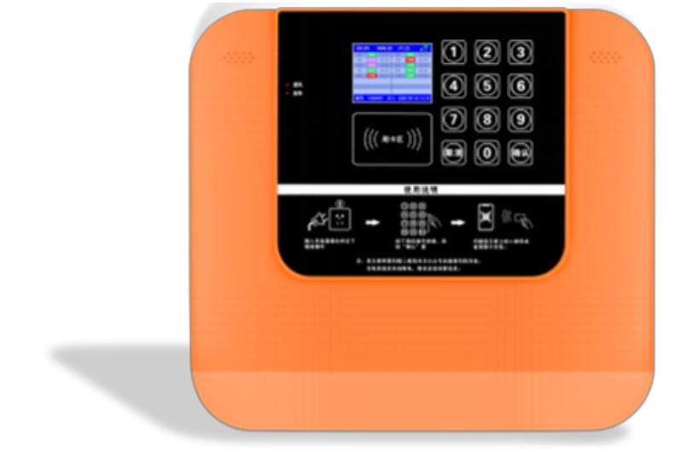

The Electric Bike Charging Pile addresses the charging challenges faced by diverse vehicle groups, encompassing electric bicycles, scooters intended for elderly individuals, and electric vehicles utilized within residential settings.
Specifications
- Input Voltage: AC220V
- Output Voltage: DC220
- Output Power: 2-7KW
- Output Interface: Available in 10/12/14/16 channels
- Protection Level: IP54
- Charging Methodology: Swipe card or scan code
- Billing Mechanism: Metered, timing, metered, monthly, or temporary options

Key Features
- Sophisticated Short Chip Detection Capability
- Voice Broadcast Functionality for User Convenience
- Door Magnetic Sensor for Enhanced Safety
- QR Code Lighting Assist for Ease of Use in Low-Light Conditions
- Temperature Alarm for Preventing Overheating Issues
- Level 6 Security for Robust Protection
Application Scenarios
Ideal for deployment in Hospitals, Schools, Parks, Residential Complexes, and Commercial Parking Facilities.

