**PARKING CONTROL**

**IQT-D01** Series

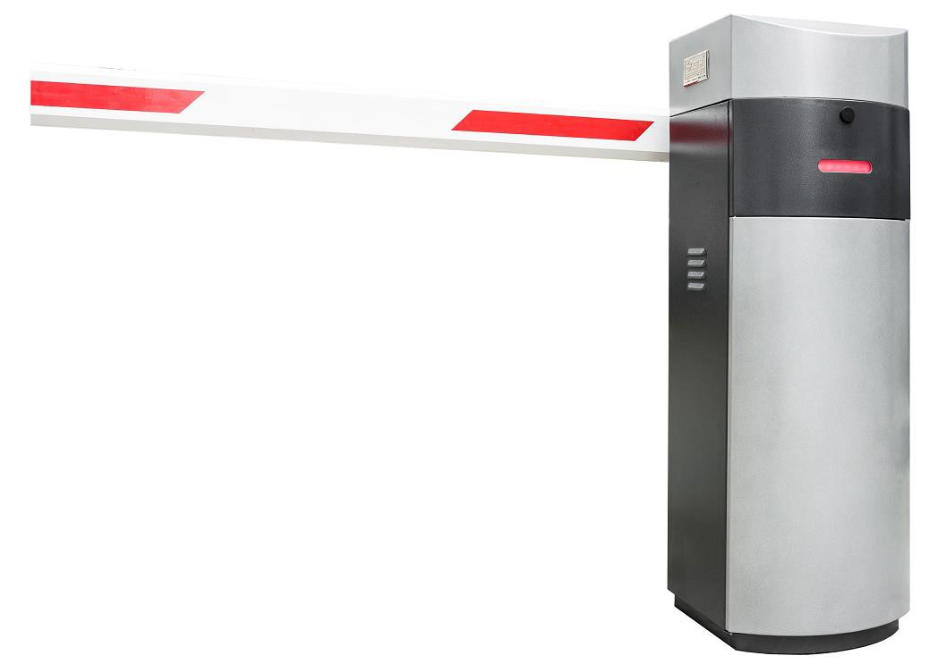

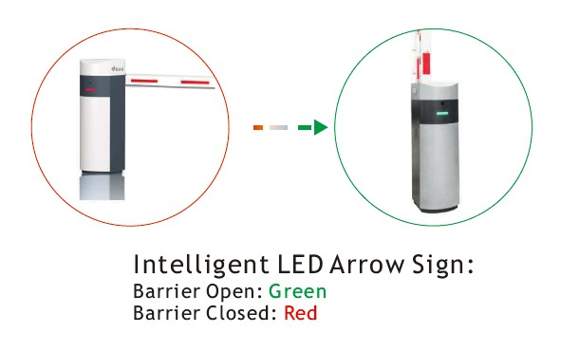

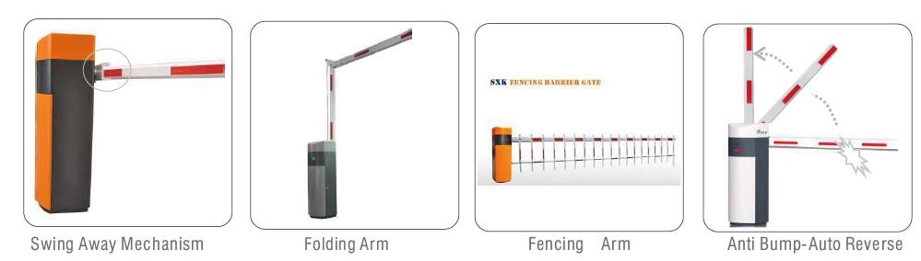

## IQT-D01 automatic barrier gate is a universal vehicular barrier which designed for heavy traffic management and large commercial applications. Typical applications include commercial, industrial, gated communities and apar tment complexes. Unique traffic LED sign, quick 1second rotation opening time with durable finishing, reliable moment engine and multiple optional features make this D01 a versatile

s o l u t i o n f o r 2 4 / 7 u s e i n h e a v y v e h i c l e t r a f f i c f l o w.

**PERFORMANCE**

Fast and smooth opening and closing (from 1sec)

Reliable electric torque motor with a non touch lever system

Designed for intensive use

Auto reverse at any time if hits an obstruction

Swing away mechanism will sheer off to prevent the barrier and boom arm (for high speed barrier gate)

**RELIABILITY**

Automatic systems over 10 years experience

Robust housing designed to protect the components, even

when crashed by a vehicle

Maintenance free torque motor, no need friction clutch

Torque motor adapt to low temperature; Cooling system with fan kit will

guarantee reliable and problem free operation in hot weather Cabinet galvanized, electrostatic powder coated finish for maximum protection

against corrosion, and can be installed in any position without the risk of

damage

**MODULARITY**

Designed for versatile applications and environments

Unlocking is convenient in case of power failure

Various accessories provided, allowing to meet all kinds of installation constraints

and various requirements in terms of security

Inbuilt spring mechanism provides a precise counterbalance for the barrier boom

and springs can be easily reset on site

**SECURITY**

Fast closing after the vehicle passing Mechanical locking in open and closed position

Various accessories enable to ensure the security level (fences, tip supports, photocells, pressure wave switch, arm illuminators...)

Manual release in the event of power failure or faulty operation

