**BLUETOOTH RFID CARD READER**

Datasheet

This long range active reader is based on Bluetooth technology, Optical excitation, sleep awake, Bluetooth communication and other high-tech automatic identification technologies

* **Technical Spec.**

|  |  |  |
| --- | --- | --- |
| Physical Properties | Size | 250mm×300mm×70mm |
| Column Height | 1100-1500mm adjustable |
| Weight | 10kg |
| Environmental Parameters | Working Temperature | -40 ~ +80 °C |
| Relative Humidity | 5%~90% |
| Waterproof, Dustproof IP | IP66 |
| Electrical Properties | Working Voltage | DC12V/2A |
| Working Current | <600mA(max) |
| Receiving Sensitivity | -110dbm |
| Serial Port Communication Baud rate | 9600bps |
| Communication Port | RS485, Wiegand26/Wiegand34 |
| Antenna Port | SMA port, 50Ω |
| Working Frequency | ISM 300-450MHz |
| Recognition Speed | ＜0.2s / 60km/h |
| Reading Interval | ＜0.5s |
| Reading Distance | 3-25m |
| Reading Angle | ＜60°(Horizontal) |
| Recognition Accuracy | 100% |
| Modulation Type | ASK |
| Output IO | 1 way activating relay output port |
| Input IO | 1 way activating Input port |
| Equipment Attribute | Machine ID | 1 byte（1-8） |
| Configured Software | Encryption Software for Reader |
| Housing | Metal plate |
| Color | Orange/ Dark Grey/ Yellow options |
| LED Indicator | Misty RED: Power; Transparent Red: Reading; Blue: Signal |
| Mounting Style | Universal Adjuster（Standard）/ Stand（Optional） |
|  |  |  |

* **Working Principle**

This long range orientation reader combines the feature of IR and RF communication; the reader emits IR scanning signal at 60°, the IR signal is encrypted, including awaken code, machine code; when the standby tag enter in the IR reading area of the reader, it will be awaked immediately, electromagnetic wave will emit tag inner code to the reader, the reader receive the card code, decoding and checkout, if data is matching, the data will be uploaded to upper machine.

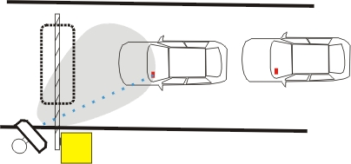

IR RECEIVING ANGLE

LONG RANGE

Reader

Standby Tag

* **Function Setup**

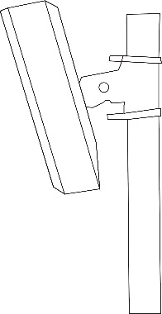External Structure

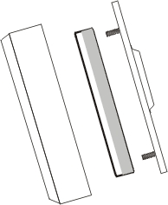 Bluetooth Reader Universal Adjuster

Stand

Metal enclosure with PMMA

Waterproof design with metal enclosure, waterproof grade is IP66. Powder coating, no color fading.

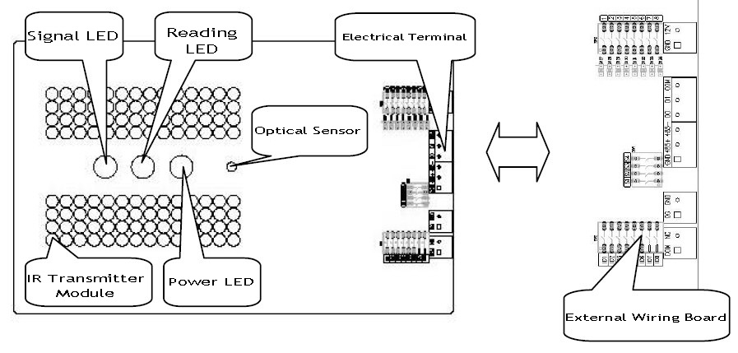Internal Structure

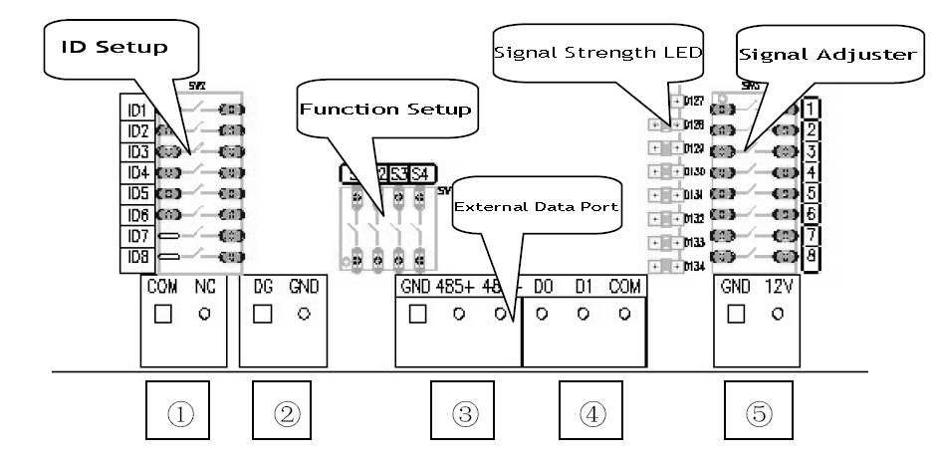

* **External Data Terminal**

1. COM/N.O relay output: Normally Open if no card reading, normally closed while reading cards; the time of closing can be adjusted(1s as default)
2. DG/GND detector input: DG port is active against low level, connect to Vehicle detector normally open port.
3. 485+/485- RS485 communication port: Baud rate 9600/19200 optional
4. D1/D0/VGND Wiegand communication port: Wiegand26/34 optional
5. 12V/GND Power input: DC9-18V input

* **Configuration Setup Introduction**

1. Function Setup

FS1: Detector triggers setup; OFF set as default, ON for activating to use detector to trigger card reading.

FS2: Data format setup; OFF set as default (9600bps/Wiegand26), if turn to ON status, its 19200bps/Wiegand34.

FS3: Dual card number of bytes chosen; Off set as default, it’s compounding the last two bytes of two card numbers(4bytes); if turn ON, it’s compounding the last four bytes of two card numbers (8bytes)

FS4: Reading Relay function; Off set as default(Disable); If turn ON, reading relay function is working, reading interval is 3 seconds for one time card reading.

1. ID Number Setup

This switch is the reader ID setup, total 8 ID number (ID1~ID8), adjacent readers must set different ID number; e.g, if the entry reader is ID1(ID1 is ON, the others are OFF), exit reader should be ID2(ID2 is ON, the others are OFF)

1. Signal Adjuster Setup

When the signal adjuster switches(8pins) are all OFF, signal strength is automatically adjust type; if one or several pins are ON, the signal strength adjuster change to manual adjust, from 1 to 8, strength is from weak to strong; If all pins are ON, signal is the strongest status.

1. Signal Strength LEDs

They are composed by 8pcs red LEDs, if IR signal is getting stronger, the quantity of LEDs from D1 to D8 will be much more than weak signal.

* **Installation Requirement**

Installing Angle:

Reader and Stand is 20~30° angle

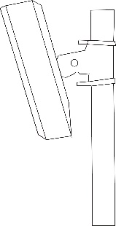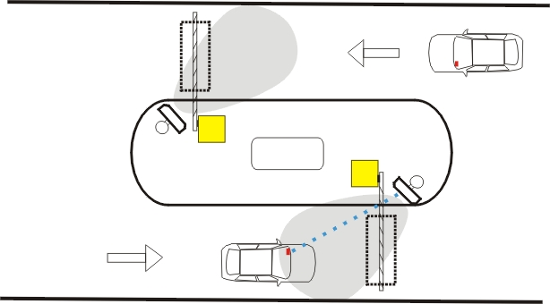

Reader is fixing behind or ahead of barrier gate, distance 0.5m

Reader and lane is 30° angle

Wiring Requirement:

Wiring between Reader and Controller:

1. Controller with Wiegand port: connecting reader and controller with 5-core wires, wire diameter is more than 0.5mm², length <50m; Power cord 2pcs, Wiegand signal line 3pcs
2. Controller with RS485 port: Connecting reader and controller with 2-core twisted pairs cable, cable diameter is more than0.5mm², length <1000m
3. Power cord: 12V/3A, linear power supplier with fine quality required

* **Reading on-site Test**

After installing the reader according to above mentioned, plug to power; put the active card behind of the windshield of car, near rearview mirror, the tag of IR awaken window face to the reader, driving the car for testing. Adjust the reader orientation according to real site to achieve best effect.

* **Parts of Card outline**

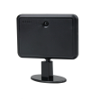

* **FAQ**

|  |  |  |
| --- | --- | --- |
| **Problem** | **Cause of Problem** | **Solution** |
| Power LED of Reader does not work | 1, Power is not switching on  2, Power module is damaged  3, Power cord polarity is in reverse | Switch on the Power, wiring correctly or replace the power module |
| Power LED lighting, working indicator doesn’t work | System crashed | Restart |
| Cannot read card | 1, card not in IR reading area  2, Card without battery or no power  3, Card is damaged  4, Reader doesn’t work properly | 1, Fix the card properly  2, Replace the card or battery  3, Replace the reader |
| Cannot read card in long distance | 1, Card battery is low  2, External interference  3, Reader fixing orientation is not so good or Signal is setting too weak | 1, Replace the card battery  2, Remove external interference  3, Adjusting the reader orientation correctly |
| No communication between reader and controller | 1, Wiring sequence is wrong  2, Electrical terminal is wrong  3, Power cord is not GND | Wiring again |