**HDMI Fiber Extender-1080P**

**User manual**

**Introduction**

This series of fiber optic extender is used to transmit 1080P high definition HDMI audio and video, USB keyboard and mouse and other signals, including multiple styles. Using single-core single-mode fiber optic cable can be transmitted, the default standard module distance for single-mode 20KM, multi-mode 3KM, and provides a HDMI output port on the sender side to connect to the local monitor. The device has a long transmission distance, low cost, easy to install, good compatibility, is a stable and efficient transmission method, widely used in computer monitoring systems, high-definition conference systems, high-definition teaching systems, high-definition digital advertising and other signal transmission areas.

**Features**

* Support HDCP1.4

* Decoding Mode MJPEG

* 802.3 Ethernet standard.

* Selectable USB mouse and keyboard extension.

* The design of pure hardware, plug and play, no need for additional software.

**Specifications**

Resolutions .................................................................................................480p,720p,1080p Audio ..................................................... Sample rate:32kHz,44.1kHz and 48kHz code I

Fiber optic interface…………………………………………………………………..SC/FC optional

Fiber optic transmission distance:……………………………………………20KM as standard, 40KM/80KM etc. can be customized.

adapter ....................................................................................................................... DC:5V/1A

The Max Power consumption .......................... HDMI sender:3W HDMI receiver:3W

Size(L-W-H) .............................................................................................…………98*78*28mm Weight .............................................................................................................................. 200g x 2

Operating Temperature/Humidity ............. 0℃-45℃/10%-80%RH(no condensation)

Storage Temperature/Humidity ................-10℃-70℃/5%-90%RH(no condensation)

**The Package contents**

Transmitter 1PC Receiver 1PC

5V Power adapter 2PCS User’s Manual 1PC

**Physical interface diagram**

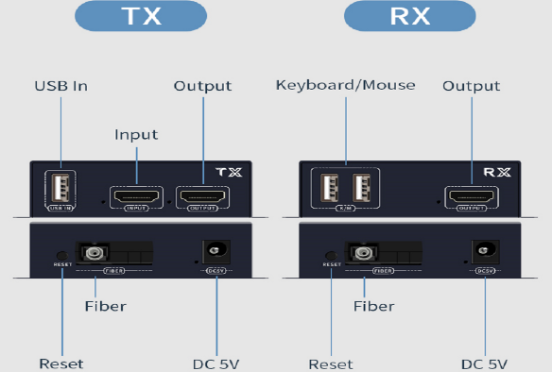

Note: USB function is optional, if you need this function, select the appropriate model.

**Connection and operation**

1, choose the national standard fiber optic cable, in addition to ensure that the host output resolution is not higher than 1920 * 1080 @ 60HZ;

2, the TX and RX connected to the power supply, the power indicator light, the device began to run;

3, the HDMI signal source into the TX INPUT interface, the indicator light is on, the signal is recognized normally;

4, the TX OUTPUT access to the local display device, the indicator light is on, the local display device can work normally;

5, with a fiber optic cable to connect the TX and RX fiber optic interface;

6, connect the OUTPUT of RX to the display device, at this time the HDMI light of RX is always on, the display device communication;

7, the connection is complete.

**Application diagrams**

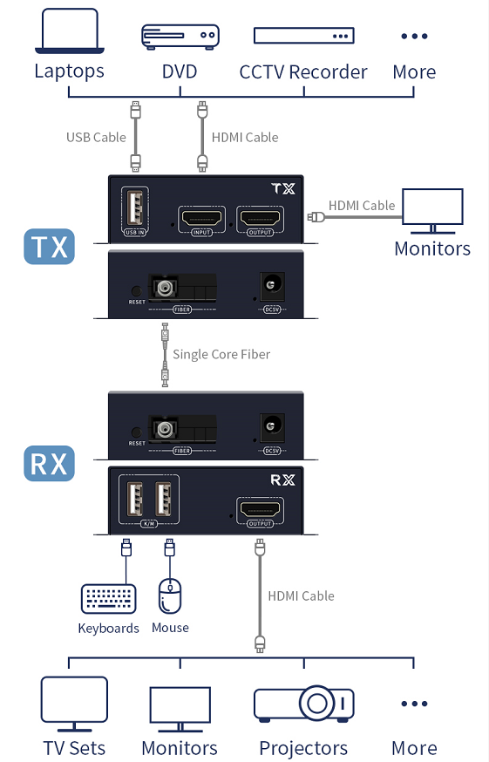

Note: USB function is optional, if you need this function, select the appropriate model.