Booking Form

By submitting this form and making the booking you confirm that you have read and agree to our terms and conditions.

Personal Information
Name : | *
Email : | *
Retype Email : | *
Home Telephone or mobile: | *
Country : | *

Tour Reservation
Tour Program :
Date of Tour (dd/mm/yy) : | * you choose the date convenient for yourself
Hotel/guest house :
Hotel address (if available) :
Total to number of adults : | * also include children above 120 cm tall
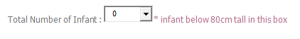  Total Number of Children : | * children below 120cm tall in this box
Your queries box :
 | By submitting this booking form you confirm that you have read and agree to our terms and conditions

